Name: Class Period:
Seasons Change
Part 1: Initial Ideas
- Why do we have seasons?

- Draw the position of the Earth in relation to the sun as it orbits during summer, fall, winter and spring.

- During which season is the Earth closest to the sun?

- Do all parts of the Earth experience the seasons at the same time? If not, what is the difference?

- Some people think that how close the Earth is to the sun affects seasons. What do you think?

Part 2: Temperatures throughout the Year around the Globe
Create a line graph of the following data. You should have one line for each city. Make sure each line is a different color and you include a key. Don’t forget to label your axes.
Average Monthly Temperatures (in Fahrenheit)
 | Jan | Feb | March | Apr | May | June | July | Aug | Sep | Oct | Nov | Dec
Antarctica | 24.1 | 17.9 | 9.9 | 3.5 | -0.8 | -4.3 | -6.5 | -7.2 | -3.6 | 4.2 | 15.3 | 23.3
Addis Ababa, Ethiopia | 61 | 63 | 64 | 64 | 65 | 64 | 60 | 61 | 61 | 62 | 60 | 60
Greenland | -24 | -27 | -25 | -11 | 12 | 30 | 35 | 32 | 15 | -4 | -17 | -19
Washington, D.C. | 34.9 | 37.3 | 45.2 | 56 | 65 | 73.3 | 78 | 76.6 | 69.7 | 58.5 | 48 | 38.1
Rio Gallegos, Argentina | 57.4 | 56.5 | 52 | 45.7 | 39.6 | 35.2 | 34.2 | 37.9 | 42.4 | 47.8 | 53.1 | 55.9

- What do you notice about temperature changes throughout the year in different parts of the world?

- What problems does this data make the distance model for seasons (the Earth being further from the sun in the winter)?

Part 3: It’s the Tilt
- Watch as your teacher models the movement of the Earth around the sun. What do you notice about the tilt of the Earth?

- How many degrees does the Earth tilt?
- How does the tilt of the Earth affect the amount of sunlight each part of the Earth receives?

- The tilt also affects the angle of sunlight. Hold a flashlight directly over the squares (at a 90° angle to the paper) below and shade in the area that is lit.
- Next hold the flashlight at a 45° angle over the squares below. Shade in the area that is lit.
Step 5 Drawing
Step 4 Drawing

- How does the angle of the light change?

- Did the amount of light coming from the flashlight change? How do you know?

- How would this relate to the amount of energy received from the sun on the Earth?

Part 4: Putting It All Together
- Using the computer, go to this seasons simulation: http://highered.mcgraw-hill.com/olcweb/cgi/pluginpop.cgi?it=swf::800::600::/sites/dl/free/0072482621/78778/Seasons_Nav.swf::Seasons%20Interactive
- Watch what happens to seasons on Earth if the tilt were 0° instead of 23.5°.
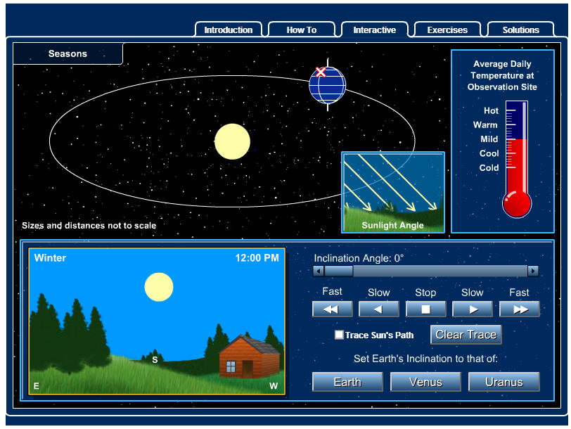
- Investigate the Earth’s actual tilt of 23.5° in the simulation.
Change Tilt here
Or here
- Finally, create your own drawing of how the Earth travels around the sun creating seasons. Be sure to label the appropriate season in the Northern and Southern Hemispheres at each point. Also, don’t forget the Earth revolves around the sun counter clockwise.

