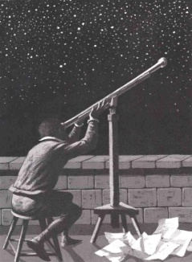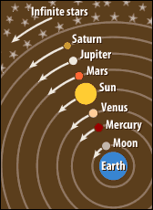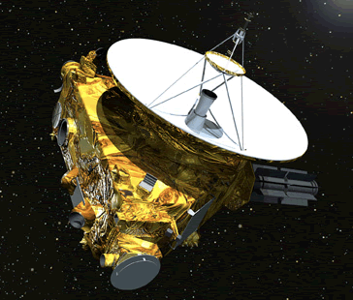[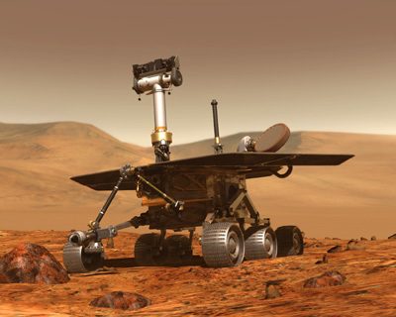](http://www.spacetoday.org/images/Mars/MarsRovers2003/MarsRover500x375.jpg)C:\Documents and Settings\e200601202\Local Settings\Temporary Internet Files\Content.IE5\HG3ASYWP\MCj02869250000[1].wmf

How has mankind’s need to explore led to our current view of the solar system?

**Heliocentrism**

**Geocentrism**

**Beginning to Make Sense of the Universe**

1. _________________ - observed 5 planets (wandering ________)
2. Aristotle (350 B.C)
   1. Earth did not move.
   2. _________ at the center of the solar system

**Our Growing Solar System**

1. _________________ - discovered in 1781
2. _________________ - discovered 1801
3. _________________ - discovered 1846
4. _________________ - discovered 1930
5. ________________________ - discovered in 1992
6. Oort Cloud, dwarf planets, and Plutoids – our understanding of the solar system continues to evolve as exploration continues
7. Ptolemy(150 A.D.) – refined the _________________ model
   1. Epicycle – smaller circles around larger ___________
   2. _________ way to explain the movement of the planets

**The Revolution Begins**

1. Copernicus (1500’s)
   1. Introduced the heliocentric (____-__________) model of solar system.
2. Brahe (1580’s) & Kepler (1600’s)
   1. _____________ made detailed astronomical observations
   2. ______________ planets move in _________________
3. Galileo (1600’s)
   1. First used a ______________ to look at the night sky
   2. Evidence for ________________________
      1. Jupiter - ______________ _____________________
      2. Venus - ______________ _____________________
      3. Sun - ________________
4. Newton (1680’s) – explained how planets stay in orbit
   1. Inertia – _________________ ________________________ ________________________
   2. Gravity –_________________ ________________________________________________

**Our First Views of the Universe**

1. Egyptians (3,000 B.C.)– studied the star _________________to determine when the Nile River would flood
2. ___________________ (3,391 B.C.)- begin measuring time and eventually create complex calendar
3. Stonehenge(2,000 B.C.) – may have connections to summer and winter _________________________

? ? ? ? ? ? ? ? ? ? ? ? ? ? ? ? ? ? ? ________________________________________________________________________________________________________________________________________________________________________________________________________________________________________