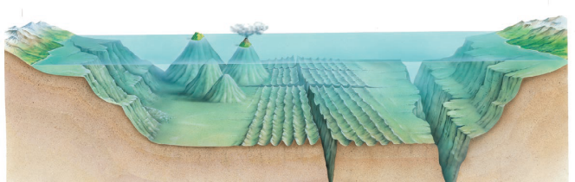
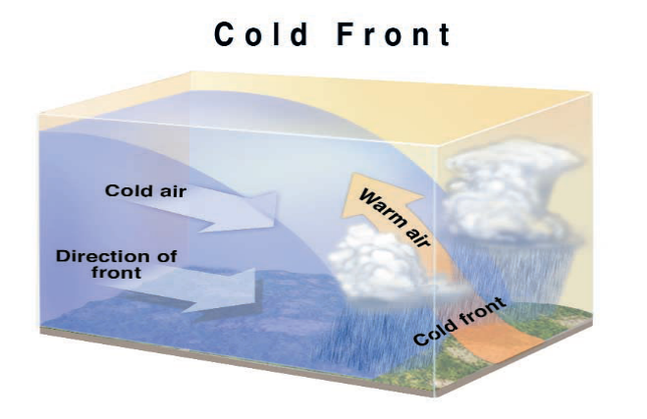
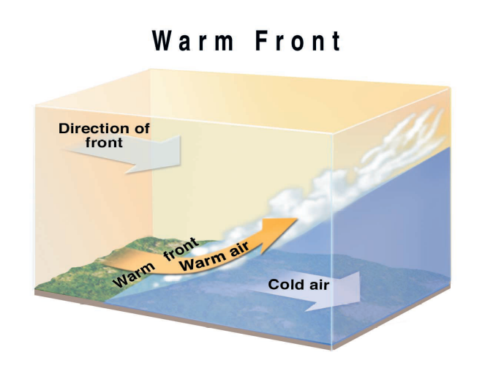

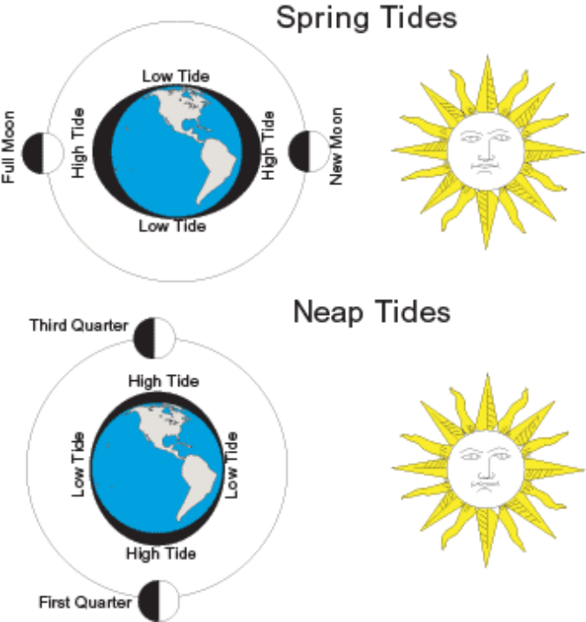

Earth Science Jigsaw Review Diagrams - Page 1

A. B. C. D. E. F. G. A. Volcanic island B. Seamount C. Abyssal plain
D. Mid-ocean ridge E. Trench F. Continental slope
G. Continental shelf _________________________________________________________
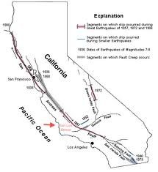
Seasons
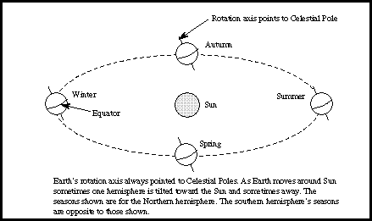
1. _Season__are caused by Earth’s tilt on its
axis and its revolution around the sun.
2. Day and night are caused by Earth’s __rotation___.
3. Inertia and _gravity_ keep the planets in their orbits.
4. _Direct_ rays from the sun cause warmer temps..
A cold front occurs when a cold air mass runs into warm air mass, but they do NOT mix.
A warm front occurs when a cold air mass runs into cold air mass, but they do NOT mix .

San Andreas Fault
1. Boundary: Transform
2. Stress: Shearing
3. Event: Earthquakes

Ocean Floor

